**Name**: Omar Mohammed Mostafa El-Nabarawy

**B.N:** 1092

**Group:** 5

**Section:** 25

**Topic:** Programming languages

**Application Brief :** I made a simple website talking about "Programming Languages" that includes what is meant by a language of programming, some types of languages and I took "C++" specifically and illustrated some points about it, also there is a link for a free-learning website that could help you learn programming easily.

**\*Screen Shots:**

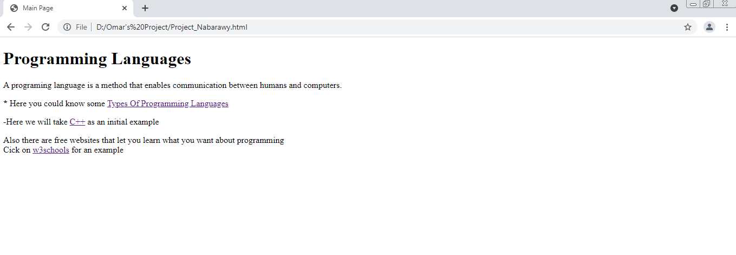

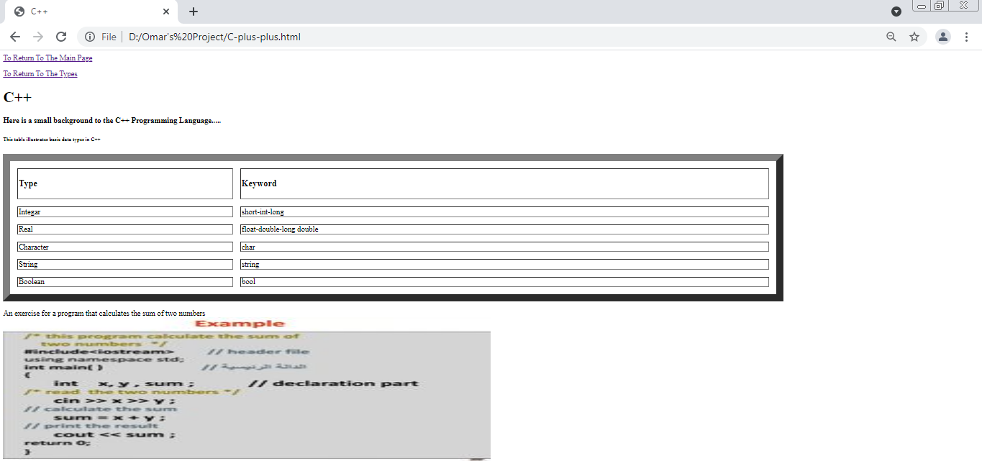

**Source Code:**



